**Practical-6:** Variants with reusable components

**Definition:** Use vector mode to edit and customize vector shapes and design different icons, and make reusable components of its vector using variants.

**Solution:**

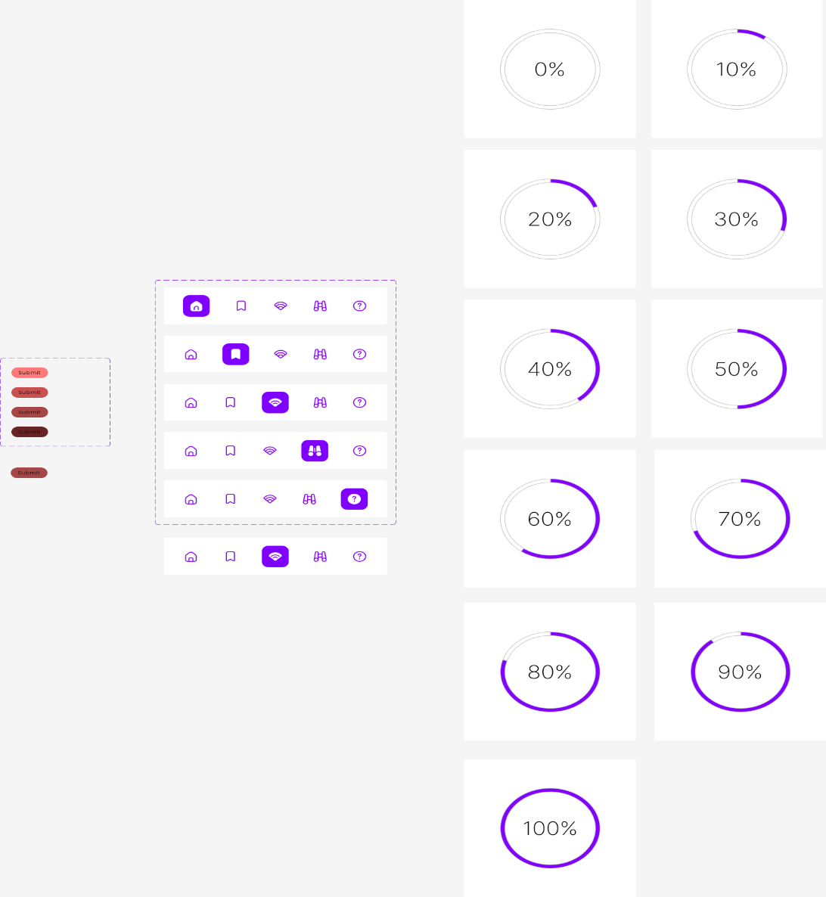

**Working:**

* First, open Figma. Add a new Figma design file.
* Rename a file as 133_Practical-6_Componet.
* In this design, the following tools are used for a particular operation:

|  |  |  |
| --- | --- | --- |
| **Tools Name** | **Use** | **Properties** |
| **Frame Tool (F)** | Used to create the main canvas | Width: 1440px, Height: 1024px Rename: Lab 6 UI Fill: #F8F8F8 (light gray) Alignment: Centered layout |
| **Ellipse Tool (O)** | To create circular progress bars | Size: 100px × 100px Stroke: 10px Stroke Style: Arc Rotation: Set to show percentage (manually rotate end point) Stroke Color: #9A00FF (vibrant purple) Background Circle Stroke: #E6E6E6 |
| **Text Tool (T)** | To show percentage values inside the circles | Font: Inter or Arial Font Size: 16px Weight: Medium Color: #000000 Center aligned (horizontally and vertically inside the circle) |
| **Auto Layout (Shift + A)** | For vertical stacking of circular progress bars | Padding: 0 Spacing between each: 20px Alignment: Top Center Frame background: None |
| **Rectangle Tool (R)** | To create the small red 'Submit' buttons | Width: 75px, Height: 26px Corner Radius: 12px Fill: Various shades of red (Top to bottom: #FF7E7E, #D96565, #B94E4E, #943C3C, #703131) Text: “Submit” (white text, center aligned) Font: Inter or Arial, 12px |
| **Auto Layout (Shift + A)** | To stack submit buttons vertically | Spacing: 6px Padding: 8px Background: Transparent or Light Gray (#F2F2F2) |
| **Frame Tool** | For horizontal icon navigation bar group (middle panel) | Width: ~300px, Height: ~320px Corner Radius: 12px Border: Dashed Purple Outline #9A00FF Fill: None Group contains rows of icons |
| **Icon Import (via Figma Community)** | Used for home, bookmark, wifi, dumbbell, info icons | Search: “Outline Icons”, “Purple Icons”, “Material Icons” Color: Default line #9A00FF, Filled icons: fill with same purple #9A00FF Size: 20px × 20px |
| **Auto Layout (Shift + A)** | To arrange icons in a row | Direction: Horizontal Spacing: 28–30px Padding: 8px vertical, 16px horizontal Background Color: #FFFFFF Border Radius: 8px Hovered/selected icons placed in filled background container (#9A00FF) |
| **Dashed Rectangle (Vector Tool or Layout Grid)** | To highlight groups for demonstration | Border Color: #9A00FF Style: Dashed Corner Radius: 10px |

* Export your design as a PNG file.